Your COPD “flare-up” action plan:

You should have a flare-up action plan you’ve agreed with your health care professional, so you know what to do if your symptoms flare up.

It’s normal for COPD symptoms to vary a bit from day to day. But if you notice your symptoms remain worse for two days or more, this is a flare-up – also called an exacerbation.

Signs of a flare-up:
- You feel more breathless than usual for 2 or more days OR
- You cough more for 2 or more days OR
- You produce more sputum for 2 or more days OR
- Your sputum changes colour or becomes stickier for 2 or more days

A flare-up might be triggered by something, like an infection or the weather, or there may be no apparent cause.

Your doctor might give you medicines to keep at home to help if you have a flare-up. This is sometimes called a RESCUE PACK. This has tablets to use if you have a flare-up. Not everyone with COPD needs a rescue pack. If you don’t have a rescue pack, check with your doctor to see if you need one.

You should make a flare-up plan with your doctor. This helps you to know what to do if you have a flare-up.

I will remember:

- To check from time to time my rescue pack medication is not out of date.
- If I cough up blood at any time – during a flare-up or when I feel well – I will contact my GP as soon as I can.
- If I have more than two flare-ups a year that require antibiotics and/or steroids, I will get a review with my GP or nurse.
- If I feel really bad, I must call 999.
- If I use the medicines in my rescue pack, I will tell my doctor or nurse within two to three days so they can keep track of my flare-ups. They can also give me new medicines to keep at home.
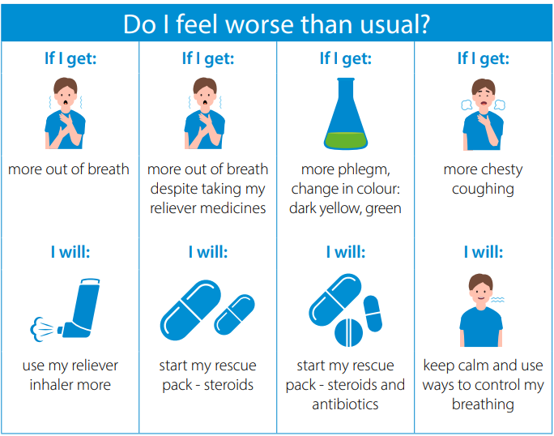
My symptoms |  | My plan
STABLE | My symptoms are normal for me. | I will continue to take my usual medication as prescribed.
STABLE | My symptoms are normal for me. | My prescribed inhalers are (include name, colour + number of puffs):
START TREATMENT AT HOME | I am more out of breath than usual, but I have no fever or chest pain. My phlegm is normal. | I will use my reliever medication (include name, colour, number of puffs + how often):
START TREATMENT AT HOME | I am much more breathless, despite taking my usual reliever medicines.  I have had these symptoms for 2 or more days. | I will use my usual medicines and the steroids in my rescue pack.
START TREATMENT AT HOME |  | Steroid (include name, dose + how many days):
START TREATMENT AT HOME |  | Prednisolone 30mg (=6x5mg tablets) once a day for 5 days
START TREATMENT AT HOME |  | I will tell my doctor or nurse within two to three days of starting my rescue pack. I will ask for a review.
START TREATMENT AT HOME |  | Phone number:
START TREATMENT AT HOME | I am much more breathless, and I am coughing up more sputum, or my sputum has changed colour.  I have had these symptoms for 2 or more days. | I will use my usual medicines and the steroids and antibiotics in my rescue pack (include names, doses and how many days):
START TREATMENT AT HOME |  | Steroid:
START TREATMENT AT HOME |  | Prednisolone 30mg (=6 x5mg tablets) once a day for 5 days
START TREATMENT AT HOME |  | Antibiotic:
START TREATMENT AT HOME |  | Amoxicillin 500mg capsules, one capsule 3 times a day for 5 days
START TREATMENT AT HOME |  | I will tell my doctor or nurse within two to three days of starting my rescue pack. I will ask for a review.
START TREATMENT AT HOME |  | Phone number:
ACTION | My breathing is much worse than normal, despite my medicines. I have chest discomfort or high fever.  People around me are noticing I seem confused. | I will call my doctor or nurse as soon as I get this bad.  A carer or family member will ring if I cannot.
ACTION |  | Phone number:
ACTION |  | If I call out of hours (18:30-08:00), my call will be re-directed to 111
ACTION | I’m struggling to breathe or have sudden shortness of breath and:  • My chest feels tight or heavy  • I have a pain that has spreads to my arms, back, neck and jaw  • I feel or am being sick | I will call 999.  A carer or family member will ring if I canno.

