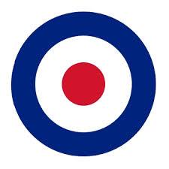
Our staff will attend TARGET training for an afternoon on:

Wednesday 29th April 2026

The Surgery will be CLOSED from 1pm

This means you will not be able to see a GP or nurse during this period, or collect a prescription.

The surgery will re-open at the usual time the following morning.
During this time, if you need advice about a health problem that cannot wait until the surgery is open again, telephone 111.

If your problem is a life-threatening emergency, telephone 999.

